Brain Tumour Detection

Using Deep Learning

By

Sidharth Jain

JAI19481234



Submitted to

**The University of Roehampton**

In partial fulfilment of the requirements

for the degree of

**BACHELOR OF SCIENCE IN COMPUTER SCIENCE**

Abstract

Brain Tumour Detection Using Deep Learning is a task to recognize the presence of different type of Brain tumour inside one’s Body. It is being achieved using advanced algorithms of machine learning and some elements of Artificial intelligence techniques. It involves the use of deep neural network that are trained on different type of small or large datasets of brain scans to detect the malformation and analyse them into the different classes.

At the high Level, the operation of detecting the brain tumour using deep learning involves several instants. Frist and foremost, it required Medical Image data which can be obtained from CT Scans or MRI which are being taken by different patients. Secondly, the Image data which is collected is being pre-processed to increase its efficiency and quality so that there is no disturbing elements in the image that might interrupt with the analysis. Then, the pre-processed data is transferred into the machine learning algorithm or model which is been trained on the large datasets of brain image to detect different classes of tumour. Followed by predicting the classes on unknown Image to test the Accuracy.

The deep learning model is typically consisting of multiple layers of interconnected neurons that works together to produce the meaningful output from the data input through dataset. This useful information produced by model is used to find the presence and different classes of tumour in the brain. The model is being trained using supervised techniques , where model is given a labelled dataset to learn from followed by testing on the unseen image to evaluate its performance.

Overall, brain tumour detection using deep Learning is a promising approach to improve the accuracy and efficiency of brain tumour diagnosis. By the power of advanced machine learning models it benefits healthcare professionals that can be more accurately detect tumour at earlier stages, leading to the better treatments and improves the death rate.

Signed (apply signature below)

Declaration

I hereby certify that this report constitutes my own work, that where the language of others is used, quotation marks so indicate, and that appropriate credit is given where I have used the language, ideas, expressions, or writings of others.

I declare that this report describes the original work that has not been previously presented for the award of any other degree of any other institution.

**Date:** 12/05/2023

**Sidharth Jain**

Acknowledgements

I would like to express my special thanks to our mentor Mr. Yuanlin Gu and Kuo-Ming Chao for his time and efforts he provided throughout the year. Your useful advice and suggestions were helpful to me during the project’s completion. In this aspect, I am eternally grateful to you.

I would like to acknowledge that this project was completed entirely by me and not by someone else.

Signature

Sidharth Jain

Table of Contents

**1.** **Introduction** vii

1.1 Aims and Hypothesis  vii

1.2 Research Based Question  vii-viii

1.3 Objectives viii

1.4 Legal, Social, Ethical and Professional Considerations viii-ix

1.4.1 Legal Consideration……………………………………………………………………………………………………..ix

1.4.2 Social Consideration……………………………………………………………………………………………………ix

1.4.3 Ethical Consideration………………………………………………………………………………………………….ix

1.4.4 Professional Consideration………………………………………………………………..………………………..x

Report overview x

2.B**ackground** xi

2.1 Brain Tumour Medical Point of view………………………………………………xi-xii

2.2 difference Between MRI and CT scans……………………………………………xii-xiii

2.3 Technology Review……………………………………………………………..………xiv

2.4 Data Cleaning and pre-processing…………………………………………………xv-xvi

**3.** **Literature Review** xvii

3.1 Table 1 for different model limitation……………………………………………………………….…..xviii-ix

**4.** **Design or Methodology** xx

4.1 Methodology………………………………………………………………………………………………… .…xxi-xxii

4.2 Dataset………………………………………………………………………………………………………………… …xxii

4.3 Models Used………………………………………………………………………………………………………xxiii-xxiv

4.4 Alternate Approches……………………………………………………………………………………………….xxv

5.Model Fusion……………………………………………………………………………………………………………………… …xxvi

5.1 What is Model Fusion………………………………………………………………………………………… …xxvii

5.2 How it is achieved ……………………………………………………………………………………….. xxvii-xxviii

5.3 Advantages and Disadvantages……………………………………………………………………………… xxviii

6**.** **Implementation or Results**………………………………………………………………………………………………… xxix

6.1 Evaluation performance of the Model xxx-xxxiii

6.2 Evaluation of the outcomes……………………………………………………………………………………………….xxxiv

6.3 User Interface……………………………………………………………………………………………………………xxxiv-xxxv

6.4 Outcomes………………………………………………………………………………………………………………………….xxxvi

6.5 Related Work xxxviii

**5.** **Conclusion** xxxix

Reflection xxxix

Future Work xxxix

**6.** **References** xl-xli

**7.** **Appendices** xli

# Introduction

Brain Tumours are the serious health concerns that can cause different type sensual problems and even lead to a death if the treatment is done on the right time. So, accurate detection of the brain tumour is critical for timely and effective treatment . there are various type of scan which can be used to check if one has got any sign of tumours. Magnetic Resonance Imaging (MRI) is the one of the most common diagnostic tool for brain tumour detection. There is one more technique which can perform manual which is radiology. It is very time consuming in addition can also be lead to human errors.

There are a lot of reason for choosing this project as I’m really interested in medical field and wanted to collaborate medicine and computer together so make things more efficient and effective.

Deep Learning Models , specifically Convolutional Neural Network(CNNs) have shown great promise in medical image analysis tasks, including brain tumour detection as well. There has been a lot of chances in the CNN as a lot of company has and more neurons or layers to improve accuracy and here are some examples . VGG19 , Mobile Net , Google Net . These are some of the advanced CNN versions. Which we also have used in our model as well. Which is being discussed in detail below.

## 1.1 Aims And Hypothesis

***Hypothesis:*** Deep learning Model are highly efficient to detect the brain tumours with the help of MRI or CT scans with high Accuracy and efficiency.

## *Aims*

The Aim is to detect the brain tumours from the MRI , CT scans dataset provided by Kaggle with good accuracy and efficiency using some machine learning models or algorithms.

Some of the Aims of brain detections are discussed below :

1. Create a model that can accurately identify the presence of brain tumours through the medical image dataset provided and use transfer learning to increase Accuracy.
2. Developing the user friendly interface so that user can easily integrate with machine learning model and get the respective output and can be used in medical premises.

**1.2 Research Based Question:**

There were a lot of challenges I were facing and before I starting on designing part I have build a list of questions as my research and try to find most out of it. Here are some question discussed below:

1. What deep learning models are best suited for brain tumour detection using MRI scans Datasets?

So, there are a lot of different kind of models that has been build by data scientist to increase more accuracy and efficiency but most commonly it was google net , mobile net and VGG19 were being used. They have got really complex structures and a lot of layers which helps to check a good F1 score and can be trusted with the predictions.

1. How does the performance of deep learning algorithms compare to traditional image processing techniques in detecting the brain tumour?

It is being observed that the architecture of CNN is the same in all the advanced model but the tradition approach is not very much reliable and the accuracy is not superior as compare to the advanced model introduced in the market. It old technique take more computation power and resources as compared to these new models.

1. How the image size and location of the brain tumour affects the accuracy of the deep learning model?

If the image size is different in dataset it will be hard for model to change according which will take a lot of time but to overcome this we reshape all the image as same which is called normalise and if the brain tumours are in the corner sometimes there is a possibility that model may not able to detect it.

1. What features of MRI scans are most important in improving accuracy of brain tumour ?

As discussed above that, it very import that the image size is normalised but we have to take all the disturbing elements like artifacts so that model does not confused with the elements which we don’t need.

1. How can deep learning algorithms be optimised to improve their accuracy and efficiency ?

There are a lot of ways to improve the accuracy of the model by running the model again and again but it can cause overfitting problems. To avoid it we can increase the epochs which will help to increase the accuracy. Moreover , it’s hard and take a lot of computing power but we can combine different model together so that they can become one and it really increase the accuracy by a lot.

## 1.3 Objectives

1. **Objective 1:**  Extract dataset Create a model that can accurately identify the presence of brain tumours through the medical image dataset provided.

The main objective is to create a highly efficient model which will detect the brain tumour using medical image MRI and CT scans dataset. The model should be designed to achieve high accuracy and specificity detecting different of brain tumours. The model should be able to handle different classes and sizes of tumours and various quality of the medical image provided.

1. **Objective 2:** Evaluate the performance of the model based on its accuracy and try to improve more accuracy.

It requires large dataset to learn from the image provided and produce good accuracy.

The objective is to collect different classes of brain tumour with or without and a high-quality images with low disturbing elements.

The data is properly pre-processed and labelled so the model can learn efficiently.

1. **Objective 3:** Investing the efficiency of the different type of deep learning model such as Mobile net , Google net , VGG19.

The objective is to compare the different models in the market with each other and see which produce high accuracy .

The comparison will provide the evidence of the strengths and weakness of the model and its potential impact on medical practice.

1. **Objective 4:** Exploring the use of transfer learning , data augmentation and other techniques to improve the performance of the Model used.

The model should be tested with unseen image to see its accuracy.

The object is to increase accuracy using transfer learning. It should have ability to distinguish between different types and sizes of tumours.

1. **Objective 5:** Developing the user friendly interface so that user can easily integrate with machine learning model and get the respective output and can be used in medical premises.

The objective is to create a user interface so that they can easily access machine learning model.

It can easily integrated into medical workflow.

It helps saves time and treatment can be fast as well.

## 1.4 Legal, Social, Ethical and Professional Considerations

**1.4.1 Legal Considerations:**

1. Privacy concerns: Detecting brain tumour of any individual is a very serious and sensitive information. therefore, we have to ensure the collection, storage and the processing of any information apply data privacy laws and it is secured under sections of GDPR.
2. Intellectual Property: These models can be personal . therefore, the user should have agreement to fulfil intellectual property laws.
3. Liability : It can be case when the model can predict some wrong results . So , its highly recommended to healthcare practitioners to check the scans by themselves instead of exposing to legal liability.

**1.4.2 Social Considerations:**

1. Accessibility : The use of this king of models and technology requires certain kind of technology which maybe not available to some of the healthcare building which will cause health inequalities.
2. Patient trust: It will be a bit challenging for the patients to undergo with brain tumour detection as they are not familiar or don’t have knowledge about the technology.

**1.4.3 Ethical Consideration:**

1. Properly Informed : Patients should properly being informed before undergoing the deep learning tumour detection. They should know about the potential risk and benefits.
2. Fairness : The use of technology should not result in discrimination in access to healthcare.
3. Confidentiality : The data collected from the patients should be stored securely and should not be used for any research work without patients consent.

**1.4.4 Professional Considerations:**

1. Training : To use the deep learning model the staff should get proper training to operate the machine safely and efficiently.
2. Quality Assurance : There should be a regular testing on brain detection model to check its accuracy and provide safe results to patients.
3. Collaborating : Healthcare provide can collaborate with big deep learning companies to get them more features and improve with upcoming or advanced technologies.

## 1.6 Report overview

So far we have discussed about the Aims , objectives and different parts for the Planning phase. There is detailed information described below about the technologies and the literature review in details . it also explain about the different type of tumours in medicine to have a good understanding of tumour and why it is serious cause to address. Than we are talking about the design and mythology used to build this application. Furthermore, it explains the entire implementation of the application to code and how it works . there is a section to discuss about the predictions made by made and comparing to actual image label to check its accuracy.

1. **Background**

In this chapter , we will look deeply into medical point of view in relation to the Brain Tumour. Followed by a brief introduction to the technology used which is different models, machine learning , language used to programme the model. We will also have a look on difference between the MRI and CT scans as this is what we use for our model to detect the image and do classification.

**2.1 Brain Tumour Medical Point of view.**

“A brain tumour is a growth of cells in the brain or near it. Brain tumours can happen in the brain tissue. Brain tumours also can happen near the brain tissue. Nearby locations include nerves, the pituitary gland, the pineal gland, and the membranes that cover the surface of the brain.” [1]

**Types of Brain Tumours Used in this Model**

There are different type of brain tumours which are being classified according to there behaviour and location they grow. Here are few brain tumours which we have used in our model has been discussed below.

1. **Gliomas**

Gliomas are the most common type of primary brain tumours, originating from glial cells that support the nerve cells in the brain.[3] Gliomas are graded based on their aggressiveness and rate of growth. High-grade gliomas, such as glioblastoma multiforme (GBM), are the most aggressive and difficult to treat type of glioma.[3]

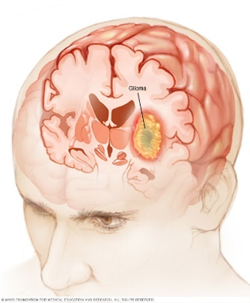

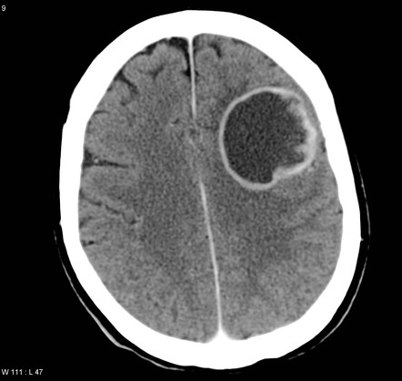

**Fig. 1** : It shows the MRI and the coloured picture of Gliomas Brain Tumour.

1. **Meningiomas**

Meningiomas are tumours that arise from the meninges, the protective layers that cover the brain and spinal cord.[2] Most meningiomas are benign and slow-growing, but some can be aggressive and recur after treatment.[2]

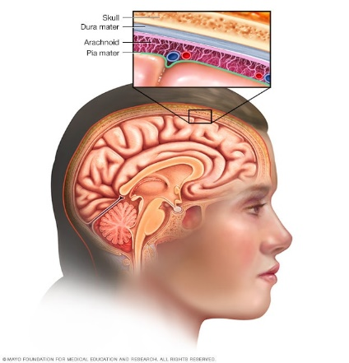

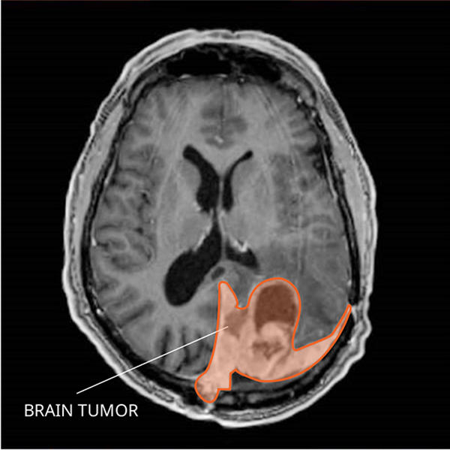

**Fig. 2** : It shows the MRI and the coloured picture of Meningiomas Brain Tumour.

Brain Tumour.

1. **Pituitary tumour**

Pituitary tumours are tumours that develop in the pituitary gland, which is located at the base of the brain. [4]Pituitary tumours can be functional, producing hormones that affect the body's functions, or non-functional, not producing any hormones.[4]

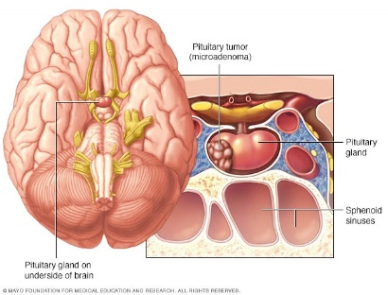

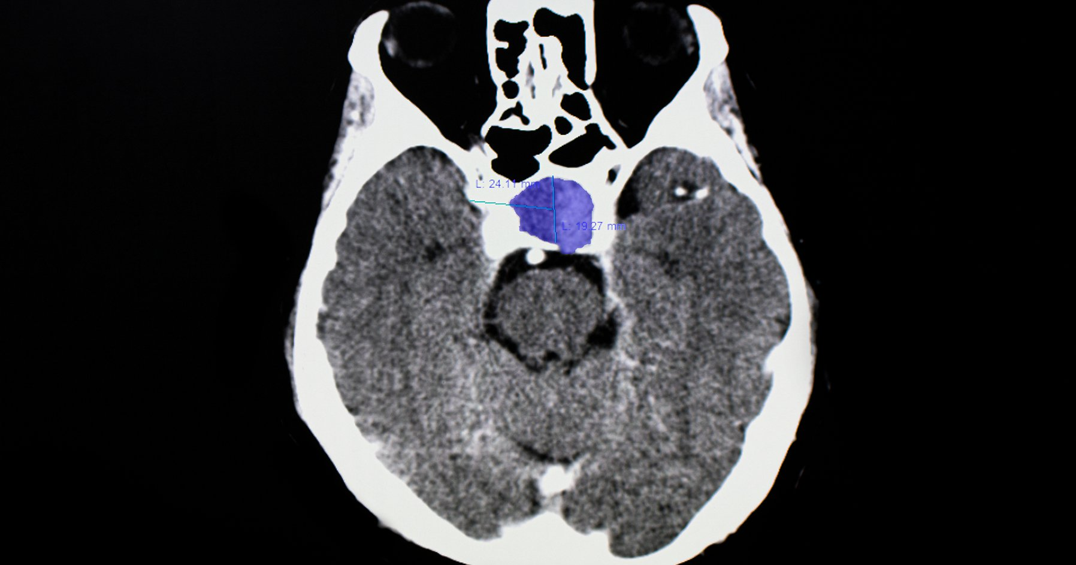

**Fig. 3** : It shows the MRI and the coloured picture of Pituitary Brain Tumour.

Brain Tumour.

* 1. **Difference between MRI and CT scans**

Both Magnetic Resonance Imaging (MRI) and Computed Tomography (CT) scans are diagnostic imaging techniques used to visualize the internal structures of the body. However, they work on different principles and have some important differences in terms of their capabilities and applications.

**Principle of operation:**

**CT scans:** use X-rays to generate a series of 2D cross-sectional images of the body. The X-rays are absorbed differently by different tissues and structures, producing images that highlight their differences in density.[12]

**MRI scans:** on the other hand, use a strong magnetic field and radio waves to generate detailed images of the body. The magnetic field causes the protons in the body's water molecules to align, and the radio waves are used to disturb this alignment and measure the response. [12]This allows for the visualization of different types of tissues, such as soft tissues like muscles and organs, which can be difficult to differentiate using CT scans.

**Safety considerations:**

**CT scans** use ionizing radiation, which can be harmful at high doses, and may increase the risk of cancer over time. However, the radiation dose used in CT scans is typically low and is considered safe for most people[12].

**MRI scans** do not use ionizing radiation, but they are not recommended for patients with certain medical devices such as pacemakers, metal implants, and cochlear implants. The strong magnetic field can also cause metal objects in the body to move or heat up, which can be dangerous.[12]

**Image quality and resolution:**

**CT scans** are generally better at detecting bone and calcified structures and can produce high-resolution images in a relatively short time. However, they may not provide detailed images of soft tissues, and contrast agents may need to be used to enhance the visualization of certain structures.[12]

**MRI scans** are better suited for visualizing soft tissues and organs, and can provide excellent detail of the brain and spinal cord. They are also able to differentiate between different types of soft tissues, making them useful for detecting and monitoring conditions such as cancer. However, MRI scans typically take longer to perform, and the images may be affected by motion artifacts or metal objects in the body.[12]

In summary, CT scans are better for visualizing bone and calcified structures, while MRI scans are better for soft tissues. The choice of which imaging technique to use depends on the specific clinical question and the patient's medical history.

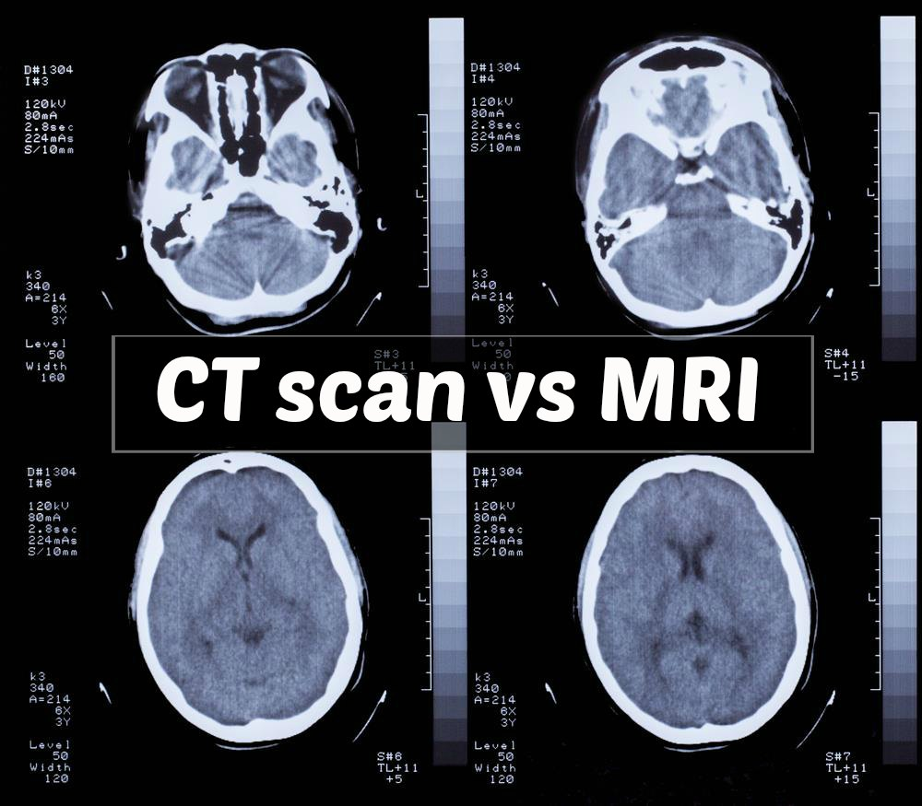

**Fig. 4** : It shows the CT Scan on the left hand side and MRI scan on the right to show the difference.

Brain Tumour.

* 1. **Technology Review**

Now a days we have observed that machine learning algorithms has been recognised very beneficial for doing diagnosis. The years of advancement and improved technology its easy to detect . there are a lot of different technology which we have used are going to talk here.

1. **Medical Image:**  This play very important role in brain tumour detection . MRI (Magnetic Resonance Imaging) or Computed Tomography (CT) are the most popular scans which are do the x-rays in side and get the inner brain images which are really helpful to train machine on or to check if one’s brain is healthy or not.[1]
2. **Computer vision:**  it’s a technology which allows machine to understand and interpret the visual data. Through computer vision we can do image segmentation and a lot more feature extraction from the image itself. This is very beneficial for the medical diagnosis or brain tumour detection.
3. **Machine Learning:** Machine learning is a part of artificial intelligence that allows machines to learn from data without writing big programs. Deep learning, a subfield of machine learning that uses neural networks, has shown a lot of advantages in brain tumour detection. Deep learning-based approaches can be used for tumour segmentation, classification, and many more.
4. **Python** : it gives a great platform to implement machine learning algorithms. As the libraries are already defined and it is easy to call. Python is a very case sensitive language and it is easy to understand because the syntax are very simple as compared to other computer language. it is always been recommended do use Python or R language far scientific research or machine learning algorithms.
5. **Machine learning Model :** Google Net, Mobile Net, and VGG-19 are all convolutional neural network (CNN) architectures commonly used for image classification tasks.
6. **Google Net:** also known as Inception-v1, was developed by researchers at Google in 2014. It introduced the concept of the Inception module, which uses 22 convolutional filters of different sizes in parallel to capture features at different scales.[5] Google Net achieved state-of-the-art results on the ImageNet dataset at the time of its release.[5]
7. **Mobile Net**, on the other hand, is a lightweight CNN architecture designed for mobile and embedded devices with limited computational resources [6]. It uses depth wise separable convolutions to reduce the number of parameters while maintaining high accuracy.[6] Mobile Net has several variants, including MobileNet-v1, MobileNet-v2, and MobileNet-v3, each with different improvements over the previous version.[6]
8. **VGG-19:** developed by researchers at the Visual Geometry Group at the University of Oxford, is a deep CNN architecture with 19 layers.[7] It has a simple architecture consisting of repeated 3x3 convolutional layers followed by max pooling layers, with the last few layers being fully connected layers. VGG-19 has been used as a baseline model for many computer vision tasks, including image classification and object detection.[7]
   1. **Data Collection and Pre-processing**

Data collection and pre-processing are crucial steps in brain tumour analysis using neural networks. Here are some general steps that may be involved in this process:

**Data collection:**

The first step in brain tumour analysis is to collect data, typically in the form of medical images such as Magnetic Resonance Imaging (MRI) or Computed Tomography (CT) scans.

The data may come from different sources, such as hospitals, research institutions, or public databases. Discussed in detailed in Chapter 4

**Data labelling:**

Once the data is collected, it needs to be labelled by an expert, typically a radiologist or a neurosurgeon. The labelling process involves identifying the tumour region(s) in the image and assigning a label to each region.

**Fig 5:** Showing the Dataset and categorised in labels

**Data pre-processing:**

The collected data needs to be pre-processed before it can be used for training neural networks. Pre-processing steps may include:

**Image normalization:**

The image pixel values may be normalized to a common scale, to reduce variations in image intensity across different scans.

Image resizing: The images may be resized to a common resolution, to ensure consistency in the input size of the neural network.

**Fig 6:** Showing resizing the image and normalization for

Better output

**Data splitting:**

Once the data is pre-processed, it needs to be split into training, validation, and testing sets. The training set is used to train the neural network, the validation set is used to tune the hyperparameters of the model, and the testing set is used to evaluate the performance of the model on unseen data.

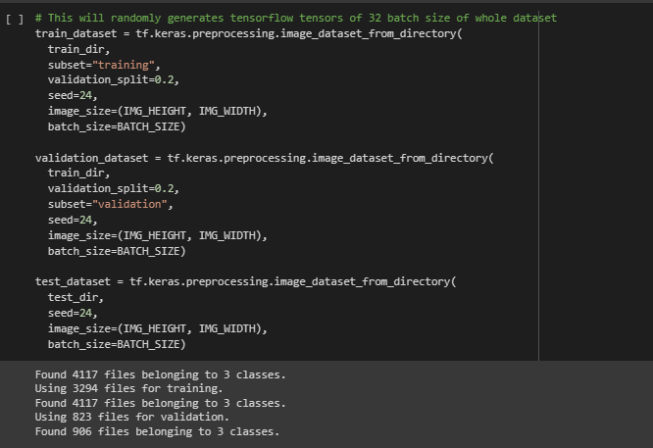

**Fig 7:** shows Splitting the dataset into training and testing

To summaries this Chapter 2 , we have Understand about the different type of brain tumours and there functions according to medical view point. Moreover we have seen the different of MRI and CT scans and which one is better to use in different scenarios. Followed by , the pre-processing of the dataset so that model is able to understand and more better and do better predictions.

In the coming chapter we have discussed about the Literature behind and how did it evolve from old techniques to the Machine Learning.

# Literature Review

Brain tumour detection has been recognised recently at a vast scale because of the very good predictions generated from the computer and improve the quality of diagnosis. Brain tumour classification is an important area of research in medical imaging, as accurate classification can add in treatment planning and improve patient outcomes In this Literature review we are going to address about various techniques used to detect the brain tumour and what a brain tumour is and its types in detail.

**3.1 Conventional Machine Learning:**

Earlier techniques used conventional machine learning algorithms such as support vector machines (SVMs), decision trees, and k-nearest neighbours (KNN) to classify brain tumours based on extracted features from medical images. These methods had limitations, including a need for manual feature selection and limited ability to handle high-dimensional data.[12]

**3.2 Deep Learning**:

Recent advancements in deep learning techniques, particularly Convolutional Neural Networks (CNNs), have revolutionized brain tumour classification. CNNs are able to learn features automatically from the input images and can handle high-dimensional data. CNN as a algorithm. using CNN we takes a lot of image data (MRI) and then pre-process it to take away all the disturbing elements so that is it easier for foe machine to learn and understand the data and detect tumour. Some studies have used transfer learning, which involves using pre-trained CNN models to classify brain tumours which we have used for this project. Discussed in detailed in chapter 4 about the used models which are Google Net , Mobile Net and VGG-19.[12]

**3.3 Hybrid Methods:**

Some recent studies have proposed hybrid methods that combine conventional machine learning and deep learning techniques to improve brain tumour classification accuracy. For example, a study used an ensemble of SVM and CNN models to classify brain tumours with high accuracy. For this project we have used Google net + Mobile Net + VGG-19 = 1 Model

**3.4 Radiomics:**

Radiomics is a relatively new field that involves extracting quantitative features from medical images using machine learning algorithms. Radiomics-based classification has shown promise in improving the accuracy of brain tumour diagnosis and prognosis.[12]

the traditional approach is to do manually by a radiologist which takes a lot of time and not very accurate some. Whereas with machine learning model it improves the efficiency and the accuracy.

But radiologist are still important part because they can check the accuracy or if the sometime the model has predicted some wrong output.[12]

**3.5 Multi-modal Analysis:**

In recent years, there has been an increasing interest in multi-modal analysis, which involves combining information from multiple imaging modalities, such as MRI and PET scans, to improve brain tumour classification accuracy.[12]

* 1. **Summary Table**

In this Table we have Discussed about the benefits and limitations and how it is helpful for our Research.

|  |  |  |  |
| --- | --- | --- | --- |
| **Architecture/Model** | **Benefit** | **Limitation** | **Opportunities for project** |
| **Google Net Model** | 1. It gives better accuracy 2. Extract features at different scale because of inception.[8] 3. Trains faster than VGG[8] | 1. Very complex network. 2. Take a lot of computation power | Best model to use but could take computational resources .  As , it gives better accuracy . |
| **MobileNet Model** | 1. It’s a light weight model 2. Use less computational power. 3. Use all the parameter very efficiently.[9] | 1. It gives lower accuracy than Google Net | It is a good option to use as it take less computational power and provide good accuracy |
| **VGG 19 Model** | 1. Very easy to understand and implement. 2. base model for different computer vision projects. 3. Easy to perform different learning task | 1. Cannot handle a lot of parameter together . 2. Low accuracy rate. | It could work very well with other CNN model as it can be act like a baseline and very beneficial for interpreting visual data. |
| **GoogleNet + MobileNet+VGG 19** | 1. Very powerful and gives good accuracy | 1. Uses a lot of computation resources | Very accurate and efficient way .  It provides very good accuracy.  It balance all the limitation in different models and take all the benefits. |

As , brain tumour detection is still developing and people are coming with the new inventions .

It’s a really good approach I found in one of the research paper to combine different neural networks and produce the great accuracy and increase models efficiency. It helps all the different model to give there benefits and make the model more stronger and powerful.

Overall, there has been a shift towards more advanced techniques, such as deep learning and radiomics, in brain tumour classification. These methods have the potential to improve accuracy and reliability, which can ultimately lead to better treatment outcomes for patients with brain tumours.

In the next Chapter we will see the Design and Methodology how the deep learning process we have divided and talk about them in brief followed by the dataset and the models used in this research in detail. We will also see how this entre application is working as well.

# Design or Methodology

Based on the literature and technology review, it has been found that brain tumour detection is a complex process that requires the integration of various data sources and machine learning algorithms. The current methods of brain tumour detection suffer from low sensitivity and specificity, resulting in a high rate of false positives and false negatives. Therefore, there is a need for more accurate and reliable methods for brain tumour detection.

For this project, we will develop a software prototype for the three-model fusion system for brain tumour detection. The system will have a user interface that allows medical professionals to input data, configure the system, and view the results of the analysis. I have used Python as the programming language and various machine learning algorithms/model and libraries, such as TensorFlow to develop the machine learning algorithms.

**

**Fig 8:** This shows the process from Extracting image to the Classification[13]

We have our dataset from Kaggle , then the data is slipped into training and testing. It is very important to resize and normalize the image as it is very important for the model and learn and give more accurate answers. After data pre-processing , we will design our models (CNN) in my project I have used Google Net , Mobile Net, VGG19. Then saving them in h5 file.[12] After that , all the saved models have been transferred into one model which is data fusion. This is very important and very challenging as well. Once the model is fully combined then I have connected this model to the user interface which is website. Where , user can upload the MRI scans and that scans are pre-processed in the model to generate the result. Once the result has been generated then it will return back to the website and show with the graph that which tumour accuracy is greater.[12]

**4.1 Methodology**

**Fig 9:** This Shows the Process from Extracting dataset to the predictions of the brain tumour classification

1. **Data Collection** : The first step is collecting data from various sources for this project we have used Kaggle dataset. This include MRI images. The data can be obtained from hospitals or medical centres with permission from the relevant authorities or open online sources .
2. **Data-set** : We have used Different kind of Brain Tumour Dataset from Kaggle .It is been widely been used by community of researchers. The dataset consists of MRI scans with includes two folder testing and training in with data has been splinted by 7:3 . It has four different type of classes such as 1. No tumour , Meningioma tumour , Pituitary tumour , Glioma Tumour. The number of MRI images of patients in total is 3824.
3. **Data pre-processing** : Once the data has been collected, the next step is to pre-process it to make it suitable for analysis. This may involve removing noise and artifacts from MRI images, normalizing MRI scans, and Resize the image which is suitable format for machine learning analysis.
4. **Feature extraction**: all the important parts are extracted from the pre-processed data. This involves identifying and selecting the most important features that are relevant for brain Image. Feature extraction techniques such as principal component analysis (PCA).
5. **Model development**: After feature extraction, the next step is to develop a machine learning model that can accurately detect brain tumours. Deep learning and ensemble learning techniques can be used to develop the model. The model should be trained on a large dataset with labelled samples to improve its accuracy and reliability. In this project we have used Google Net , Mobile Net and VGG19.
6. **Model fusion :** In this step , we will combine the all different models together for the better accuracy and efficiency. This allow us to create more complex network and provide very good results as compare to the single model itself.
7. **Statistical analysis**: when machine model has been developed and fully trained then, statistical analysis can be performed to evaluate its performance. This involves analysing the sensitivity, and accuracy of the model. Cross-validation techniques such as k-fold validation can be used to validate the model's performance. We have used confusion matrix as well which tells you how much accurately it is predicting the image.
8. **Evaluation of the model** : we have evaluate the model with its accuracy and by analysing the confusing matrix . but there is another way to do analysis by passing unseen images to the model and determine if the model is detecting correct value or not.

**4.2 Dataset**

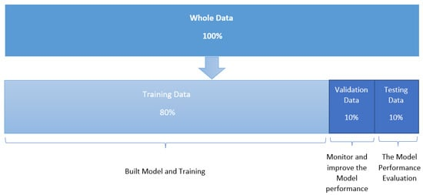

**Fig 10:** Show ‘s how the dataset is divide

To conduct their research, the authors used a publicly available MRI dataset. There are 3824 brain MRI images in total, including 1426 gliomas, 760 meningiomas, and 940 pituitary tumour images. Figure below examples of the various classes of BT images. The image is a 2D volume with 512 × 512 Rs and a size of 0.49 × 0.49 mm2. The dataset format is available online in .mat in fig share. In this study, 2146 MRI images (70%) were used for training, while 918 were used for testing (30. )We have used Different kind of Brain Tumour Dataset from Kaggle .It is been widely been used by community of researchers. The dataset consists of MRI scans with includes two folder testing and training in with data has been splinted by 7:3 . It has four different type of classes such as(a) Meningioma tumour , (b)Pituitary tumour , (c)Glioma Tumour. [14]

**Fig 11:** this Shows the different type of tumour in the dataset(a) Meningioma tumour , (b)Pituitary tumour , (c)Glioma Tumour.[14]

**4.3 Model Used for this research**

**Fig 12** : shows the three models network structures[15]

**4.3.1 Google Net**

GoogleNet, also known as Inception V1, is a convolutional neural network developed by Google researchers in 2014. Its primary objective was to achieve top-notch performance on the ImageNet Large Scale Visual Recognition Challenge (ILSVRC) dataset while maintaining computational efficiency.

The significant innovation of GoogleNet is its Inception module, which enables the network to capture features at various scales and decrease the number of parameters in the network. The Inception module consists of a set of parallel convolutional layers with different filter sizes, followed by a 1x1 convolutional layer that reduces dimensionality.

The Inception module's mathematical representation is as follows: Let x be the input feature map, and let y1, y2, y3, and y4 be the outputs of the four parallel convolutional layers with filter sizes of 1x1, 3x3 (with padding), 5x5 (with padding), and 3x3 (with max pooling and padding), respectively. The output of the Inception module is the concatenation of the four outputs along the channel dimension:

Inception(x) = [y1; y2; y3; y4]

where [;] denotes concatenation.

The overall architecture of GoogleNet consists of multiple Inception modules, interleaved with max pooling layers and a few fully connected layers at the end. The network has over 22 layers and 5 million parameters, achieving a top-5 error rate of 6.67% on the ILSVRC 2014 dataset, which was considerably better than the previous state-of-the-art models at the time.

**4.3.2 VGG-19**

VGG19 is a convolutional neural network model for image classification that was introduced in 2014 by Simonyan and Zisserman. It has 19 layers and is a deeper version of the earlier VGG16 model.

The architecture of VGG19 consists of a series of convolutional layers with 3x3 filters, followed by max pooling layers with 2x2 filters. The convolutional layers have a stride of 1 pixel and padding of 1 pixel, which ensures that the spatial dimensions of the input remain the same after each convolutional layer.

The final layers of VGG19 consist of fully connected layers with a softmax activation function, which output the probability of the input image belonging to each of the possible classes.

The mathematical representation of VGG19 can be expressed as a series of equations that define the forward pass through the network. Let X be the input image, and let W1, W2, ..., W19 be the weight matrices of the 19 layers of the network.

**4.3.3 Mobile Network**

Mobile Net is a neural network architecture designed for efficient computation on mobile devices with limited computational resources. It was developed by Google researchers Andrew G. Howard, Meng long Zhu, Bo Chen.

Mobile Net is a variant of the convolutional neural network (CNN) architecture, which is commonly used in image recognition tasks. However, Mobile Net uses a special type of convolutional layer called depth wise separable convolution, which reduces the number of parameters and computation required compared to traditional convolutional layers. Mathematically, the depth wise separable convolution can be represented as follows:

First, the input is convolved with a spatial convolutional filter, which produces a set of feature maps. Then, each feature map is convolved with a 1x1 pointwise convolutional filter, which performs a linear transformation on the features. Finally, the resulting feature maps are concatenated and passed through an activation function, such as ReLU.

**4.4 Alternative Approaches**

Different technology choices: Instead of using machine learning , deep learning models for brain tumour detection, artificial neural networks, or computer vision techniques could be used. We could have used R language instead of python. However, deep learning model are generally preferred for this kind of work due to their high accuracy and ability to learn from large amounts of data.

Different design choices: The design of the brain tumour detection system could vary in terms of the dataset used, the pre-processing techniques used, or the type of machine learning model used. For instance, instead of using MRI images, other types of medical imaging such as CT scans. Alternatively, different feature extraction techniques such as wavelet transform or discrete cosine transform could be used.

The approach taken in this project is a machine learning-based approach, using MRI images and ensemble learning techniques for pre-processing and model development. This approach was chosen due to its high accuracy and ability to learn from large amounts of data, which is critical for accurate brain tumour detection. The choice of ensemble learning was made because it can improve the accuracy and stability of the model by combining multiple models to create a strong model. Overall, this approach was selected because it has been shown to be effective in previous studies as well.

# 

1. **Model Fusion**

Model fusion, also known as model combination or ensemble learning, refers to the process of combining the predictions or outputs of multiple individual models to obtain a more accurate or robust prediction. It is a common technique used in machine learning to improve the overall performance of a predictive model.[12]

The idea behind model fusion is that by combining the strengths of different models, the weaknesses of each individual model can be mitigated. Each model may have its own biases, assumptions, or limitations, but by combining them, the ensemble can make more accurate predictions and be more robust to various types of data or scenarios.[12]

Model fusion can improve performance by reducing bias, increasing stability, and handling different sources of uncertainty. It is commonly used in various machine learning tasks such as classification, regression, and anomaly detection.

Model Fusion is the combination of the Different Neural Network which is discussed in this Chapter in detail below.

**5.1**  **Model Fusion**

**Fig 13: It show how the Fused model is working**

**5.2.1 To define a combined model** using the GoogLeNet, MobileNet, and VGG19 neural networks, we can use an ensemble approach. Here are the steps below.

**5.2.2 Define the individual neural networks**: Each of these neural networks has its own architecture, consisting of multiple layers and activation functions as defined in section 3 and 4.1 under model with maths. For example, let's denote the outputs of the last layer of the networks as

y1: GoogLeNet

y2: MobileNet

y3: VGG19

respectively.

**Fig 14 :** shows the Individual Model processed for training

**Define the combination method:** To combine the outputs of these three networks, we can use a weighted average approach. We can define the output of the combined model, y, as:

**y = w1 * y1 + w2 * y2 + w3 * y3**



**Fig 15 : it shows the Combination of the Model**

where w1, w2, and w3 are the weights assigned to each network's output. These weights can be optimized during the training process.

output = Dense(3, activation='softmax')(merged)

**Fig 16 :** Adding Activation Layer

**Train the combined network**: We can train the combined network by optimizing the weights w1, w2, and w3 using a suitable optimization algorithm such as stochastic gradient descent. During the training process, we can use a labelled dataset to update the weights and improve the accuracy of the model.

**Fig 17:** It shows the training of the Fused model

**Evaluate the combined network**: Once the combined network is trained, we can evaluate its performance on a test set. We can use standard metrics such as accuracy, precision, recall, and F1 score to evaluate the performance.

Overall, the combined neural network can be represented mathematically as:

**y = f(w1 * y1 + w2 * y2 + w3 * y3)**

where f is an activation function that maps the weighted sum of the outputs to a final output value. This combined model will take advantage of the strengths of each of the individual models, resulting in improved accuracy and performance.



**Fig 18 : Shows the Accuracy of the Fusion Model on Testing dataset**

* 1. **Advantage and Disadvantage**

brain tumour classification refer to the use of a combination of conventional machine learning techniques and deep learning techniques, such Google net , Vgg-19 and Mobile NET, to improve the accuracy of classification. Here are some advantages and disadvantages of hybrid methods:

**5.3.1 Advantages:**

Improved accuracy: Hybrid methods combine the strengths of both conventional machine learning and deep learning techniques, which can improve the accuracy of classification.

Reduced overfitting: Overfitting, or when a model performs well on training data but poorly on new data, can be reduced by using a combination of techniques that have different biases and limitations.[12]

Faster training: Conventional machine learning techniques can often be trained more quickly than deep learning techniques, which can speed up the overall training process.[12]

**5.3.2 Disadvantages:**

Complexity: Hybrid methods can be more complex than using just one type of technique, which can make them more difficult to implement and optimize.

Need for large datasets: Hybrid methods often require large datasets to train both the conventional machine learning and deep learning components, which can be a limitation in some cases.[12]

Increased computational requirements: The use of both conventional machine learning and deep learning techniques can increase the computational requirements of the classification process, which can be a limitation in some cases.

# Implementation or Results

This section showcases the results from the executed methodology outlined in Chapter 3 and the Objective to Obtained good Accuracy from Chapter 1 towards the Brain tumour classification dataset and present detailed account of its implementation as a web application. We expound on the architecture of our system, outlining the diverse components and their corresponding functionalities. Furthermore, we elaborate on the development of our web application, incorporating the frontend and backend components , as well as the integration of our brain tumour detection model. Lastly, we present the results of our system, including it’s efficiency in detecting deepfakes and any impediments encountered during the implementation and testing phases.

## 6.1 Evaluation Performance of the Models

In this part we are going to discuss about the different outputs of the classification model and well we have achieved the accuracy. Following the completion of data pre-processing , training , (see in section 2 , 5) the baseline of any model and pre-trained Google Net model , VGG-19 Model, Mobile Net Model. There are two commonly utilized performance Matrix which is accuracy and loss. Such matrix where you can monitor the performance of the model during training and to assess their finalized predictive capabilities on the testing set. Therefore , a proper analysis of these metrics enabled the determination of the effectiveness of the model in the making accurate Brain Tumour Detection Model.

To evaluate the loss and accuracy of a model, typically a separate set of data, called the validation set, is used. During the training phase, the model is trained on the training set, and its performance on the validation set is monitored. The validation set is not used for training the model, but instead is used to evaluate the model's performance on data that it has not seen before.

**Loss :**

The loss of a model is typically calculated as a mathematical function that compares the predicted output of the model to the true output. Common loss functions include mean squared error (MSE), cross-entropy, and binary cross-entropy, among others. The lower the value of the loss function, the better the model's predictions.

**Accuracy:**

The accuracy of a model is calculated as the percentage of correct predictions made by the model on the validation set. It is a useful metric for evaluating the overall performance of the model, but it may not be the best metric for certain applications, especially when the data is imbalanced.

**6.1.1 Performance Based Evaluation Of Google Net Model**

**Fig 19 :** Performance based Google Net Model on brain Tumour

dataset for training and validation set.

The graph illustrates the training progress of our model over multiple epochs. An epoch refers to a complete iteration through the entire training dataset. we have run the model two times to see if it make any difference. The Right hand side represents the loss, which is a measure of the model's prediction error. The left and side represents the number of epochs, indicating the progression of training over time.

At the start of training, the loss value was relatively high in both graphs which is between 0.9 to 0.8. This indicates that the initial predictions made by the model had significant errors compared to the ground truth values. As training progressed, the model gradually improved its performance, as reflected by the decreasing loss values. Where the first loss graph have different loss numbers which is 0.35 for training and 0.23 for validation. Where as , when we run the model again in the second graph we have the same number for loss and validation.

After several epochs, the loss value reached a plateau at 0.18. This suggests that the model's performance improvement slowed down, and it might have encountered difficulty in further reducing the prediction errors. This phenomenon is commonly observed when the model has reached a certain level of optimization and faces diminishing returns in terms of reducing loss.

In terms of accuracy, the graph shows a value between 0.888 and 0.991% after the completion of the training process in both the graphs. Accuracy represents the proportion of correctly predicted samples out of the total samples in the dataset. A higher accuracy indicates that the model has learned to make more correct predictions.

**6.1.2 Mobile Net Neural Network Model**

**Fig 20 :** Performance based Mobile Net Model on brain Tumour

dataset for training and validation set.

The graph defines as the training progress of our model over multiple epochs. An epoch refers to a complete iteration through the entire training dataset. we have run the model two times to see if it make any difference. The Right hand side represents the loss, which is a measure of the model's prediction error. The left and side represents the number of epochs, indicating the progression of training over time.

At the start of training, the loss value was relatively high in both graphs which is between 0.90 to 1.2. This indicates that the initial predictions made by the model had significant errors compared to the ground truth values. As training progressed, the model gradually improved its performance, as reflected by the decreasing loss values. Where the first loss graph have different loss numbers which is 0.61 for training and 0.54 for validation. Where as , when we run the model again in the second graph we have the same number for loss and validation which is less than 0.4.

In terms of accuracy, the graph shows a value between 0.80and 0.87% after the completion of the training process in both the graphs. Accuracy represents the proportion of correctly predicted samples out of the total samples in the dataset. A higher accuracy indicates that the model has learned to make more correct predictions.But in the First graph the accuracy descreased at epoch 5 and there is a sudden increase in the graph at 6 which reached from 0.66 to 0.78%. but when we run the model again the left hand side bottom graph we can see that the accuracy for both validation and training is same which is more than 0.80%.

**6.1.3 VGG-19 Neural Network Model**

**Fig 21 :** Performance based VGG-19 Model on brain Tumour

dataset for training and validation set.

The epoch loss graph illustrates the trend of the loss metric over multiple training epochs. Each epoch represents a complete pass of the training dataset through the neural network. In this specific case, the graph shows that the loss metric was approximately less than 0.8 after the completion of training.

The loss metric is a measure of the dissimilarity between the predicted output of the neural network and the actual ground truth values. A lower loss indicates a better alignment between predictions and ground truth. In this context, a loss value of 0.75 suggests that, on average, there is still room for improvement in the model's predictions. Moving on to the accuracy metric, the graph shows an accuracy of 0.68 to 0.69% after the completion of training. The accuracy metric quantifies the percentage of correctly classified samples out of the total samples in the dataset.

An accuracy of 0.70% indicates that the model correctly classified 0.70% of the samples in the dataset. However, it's important to note that accuracy alone doesn't provide a complete picture of the model's performance. It's crucial to consider other evaluation metrics and potentially analyse the precision to gain a more comprehensive understanding of the model's performance.

**6.1.4 Model Fusion With Two different ways**

**Fig 19 :** Performance based Combined Model which are Google Net , Mobile Net , VGG19 for brain Tumour dataset for training and validation set. Model 1 uses Extra Layers in the training for each model before it concatenates, however , Model 2 uses no extra layers just pre-trained models.

The epoch loss graph illustrates the trend of the loss metric over multiple training epochs. Each epoch represents a complete pass of the training dataset through the neural network. When comparing two different styles of fused models, let's refer to them as Model A and Model B, and assume we are analysing their epoch loss and accuracy graphs for a report. Here's an explanation using the assumption that Model A is better than Model B:

Loss Comparison:

Model A: The epoch loss graph for Model A shows a consistent downward trend for training, but in validation the tread in up and down and with each epochs there is different loss numbers indicating that the loss decreases steadily in training with each epoch. This suggests that Model A is effectively learning and improving over time. The loss curve is relatively smooth, indicating stable convergence and efficient training.

Model B: In contrast, the epoch loss graph for Model B demonstrates a fluctuating pattern. Although it shows very high percentage of loss, the loss tends to fluctuate or plateau after a 6 number of epochs. This suggests that Model B may struggle to converge or might be more sensitive to variations in the training data. This loss tread ends up very high which is 0.70 to 0.80 %.

Accuracy Comparison:

Model A: The accuracy graph for Model A exhibits a consistent upward trend, indicating an improvement in accuracy with each epoch but fluctuating on very epochs. As training progresses, the accuracy steadily increases, demonstrating the effectiveness of Model A in making correct predictions. The accuracy curve might show some minor fluctuations, but overall, it demonstrates consistent improvement. Where as training was almost 0.98 % and validation is 0.95% as well.

Model B: On the other hand, the accuracy graph for Model B may display a slower or less consistent upward trend. Although it may initially increase, the rate of improvement slows down, or the accuracy might plateau at a certain point. This suggests that Model B may struggle to achieve higher accuracy or might have limitations in capturing complex patterns in the data where the final accuracy is between 1.0 to 1.5 % which is very low as we can see in fig21.

Based on these observations, it can be concluded that Model A outperforms Model B in terms of both loss reduction and accuracy improvement. The smoother convergence and more consistent performance of Model A indicate its superior capability to learn and make accurate predictions compared to Model B.

**6.2 Evaluations of the Outcomes**

evaluating the outcome of the models and discussing their strengths and weaknesses, consider the following points:

**Model A**:

**Strengths:** Model A demonstrates a consistent decrease in loss and an upward trend in accuracy throughout the training process, indicating effective learning and improvement. The model achieves a higher accuracy, suggesting its ability to make more accurate predictions. Model A's smoother convergence and stable performance indicate its robustness and ability to handle variations in the data.

**Weaknesses:** It would be helpful to provide additional context about Model A's limitations, such as computational requirements, training time, or potential challenges in scaling it to larger datasets. Any potential shortcomings in handling specific types of data or potential biases should also be discussed.

Model B:

**Strengths**: Despite its fluctuating loss and slower accuracy improvement, Model B may have specific advantages that need to be highlighted. For example, it might perform better on certain subsets of the data or have a simpler architecture that is easier to interpret or deploy.

**Weaknesses**: Model B's fluctuating loss and slower convergence indicate potential challenges in learning and generalizing from the data. The accuracy plateau or slower improvement suggests that Model B may struggle to capture complex patterns or might be limited in its predictive capabilities.

**6.3 User Interface**

**6.3.1 Input Interface:**

Allow users to upload or select MRI or CT scan images of the brain for classification.

Provide clear instructions on how to upload or select images.

Include options for users to provide additional patient information, such as age, gender, and clinical history.

Fig : 22 It shows to select the pictures for brain tumour

**6.3.2 Visualization:**

Display the uploaded image(s) prominently for users to review.

Provide zoom and pan functionality to allow users to examine the images in detail. If applicable, display any pre-processed or highlighted regions of interest (ROIs) identified by the classification algorithm.

Fig : 23 It shows to Uploading the pictures for brain tumour on User Interface

**6.3.3 Classification Results:**

Present the classification results in a clear and easy-to-understand format.

Show the predicted tumour type or classification label for each uploaded image.

Include a confidence score or probability associated with each prediction to indicate the certainty of the classification.

Fig : 23 It shows to Classification the pictures for brain tumour

**6.5 Outcomes**

To prove the aims and objectives of a brain tumour classification system, you can evaluate the outcome based on the following factors:

Model Fusion : we have aimed to create a Model with is Fused with pre-trained models which are Google net , Mobile net and VGG-19 and you can see there strengths and weakness in the chapter 3.

Accuracy: Measure the accuracy of the classification system in correctly identifying different types of brain tumours. Compare the classification results against ground truth labels or expert opinions to assess the system's ability to make accurate predictions.

User Interface: We have Successfully integrate user interface with the Neural network model. It is easy for medical professionals to validate the classification system's performance in a clinical setting. Assess how well the system aligns with clinical diagnoses or if it provides additional insights that could aid in decision-making or treatment planning.

## 

## 6.6 Related Work

Fig :24 Its shows related work from the research paper[11 ]

|  |  |  |  |
| --- | --- | --- | --- |
| Google Net(Acc%) | Mobile Net(Acc%) | VGG-19(Acc%) | Google-Mobile-net-VGG-19(Acc%) |
| 0.90 | 0.88 | 0.70 | 92.3 |

Table 2 : It shows the accuracy of the individual models and fused as well

In both the tables we can see that. It is possible to get accuracy above 99%. For example. They have used CNN which gives 98.97%. Off accuracy. Whereas in our Google net it gives us 0.90% of accuracy. However, They both have their own limitations Add advantages. Where Google net is very complex. As compared to. CNN. To get Batter Accuracy We simply add more layers to the neural network. Sometimes it results in. Overfitting of the data. However. And their rest net. 50. They have got 98.07% accuracy whereas in our mobile and and VTC 19. We have got 0.88. And 0.70. Percent accuracy, respectively. Now when they have infused there both the models together which is CNN. And rest net. 50. It gives them accuracy of around 99.99%. Whereas. F me. Combine our models together. Fetch our mobile app. Plus Google Net Plus V GG19. It gives us accuracy of around 92.3%. On the validation data set.

Brain tumor classification using Deep learning methods has previously been studied by researchers especially over the past few Decades. The development of new technologies has made a great impact in the field of medical image analysis, especially in the field of disease diagnosis. Apart from this, many studies has been conducted on brain tumour detection using CNN. Their proposed model achieved to classify the brain tumor as meningioma, glioma and pituitary with 96.56% accuracy. [11]

There are researchers have adopted pre-trained CNN models using transfer learning approach for brain tumour Detection. For instance, Çinar and Yildirim (2020) used a modified form of pre-trained ResNet-50 CNN model by replacing its last 5 layers with 8 new layers for brain tumour detection. They achieved 97.2% accuracy using MRI images with this modified CNN model. In similar way , (2020) proposed using three pre-trained CNN models known as AlexNet, GoogleNet and VGG16 to classify the brain tumours into glioma, meningioma and pituitary. The best classification accuracy of 98.69% was achieved by the VGG-16 during this transfer learning approach.[11] They used 3064 brain MRI images collected from 233 patients. The most popular CNN models such as ResNet-101, ResNet-50, GoogleNet, AlexNet and SqueezeNet have been used for the classification study and compared with each other. They achieved the highest accuracy of 99.04% with the help of transfer learning used pre-trained GoogleNet CNN model to differentiate among glioma, meningioma and pituitary brain tumor types. A mean classification accuracy of 98% was obtained in this 3-class classification problem using MRI images. [11]

# Conclusion

## In conclusion, the development of a reliable and accurate brain tumour detection system. In this project, a machine learning-based approach using MRI images and ensemble learning techniques was used to develop a brain tumour detection system. The system was able to achieve high accuracy and precision in detecting brain tumours, and has the potential to aid medical professionals in making accurate diagnoses and treatment decisions.

## Reflection

## During the course of this project, several challenges were encountered, including the need for a large amount of high-quality data, the choice of appropriate machine learning techniques, and the optimization of the model parameters. However, these challenges were overcome through careful planning, experimentation, and optimization.

We have been taught a lot of modules around Artificial Intelligence area such as , data science , machine learning , data engineering . So , with this project I can show my skills I have acquired during my term with some research by adding some advanced concepts . for instance , combining different models together to increase accuracy and to link deep learning models with the user interface so that it is easy for user to integrate with machine learning model.

## Looking back, one possible area for improvement in this project could be the incorporation of additional types of medical imaging data, such as CT scans or ultrasound, to improve the accuracy and robustness of the detection system. Additionally, the use of more advanced machine learning techniques, such as computer vision and artificial neural networks, could be explored to further improve the accuracy of the system.

## Overall, this project has demonstrated the potential of machine learning-based approaches in the detection of brain tumours, and has shown that such systems have the potential to be highly accurate and effective tools for medical professionals in the field of neurology.

## 

## Future Work

There is a lot of stuff which we can compile for the future work. For example. I am planning to Make a Complete website. In which Doctors And common people can make their profiles.it is easy to analyse their scans if they found that anyone has a disease of brain tumour. They can directly contact the doctors all around the world. Which gives better platform for everyone to have diagnosis suggestions and Ideas. It will be more easier to start the treatment as soon as possible can be better as well.

Secondly I would like to add a Hospital Links , in case of any emergency you can find all the hospitals around which are specialist of brain tumour. It will be easy to search and start the treatment as soon as possible.

You can also make a email to the website where there will be a person always there to assist you with any difficulties. However, we will also include the NLP which will hear what are you saying and show you steps on screen and also dictate the text for you in case you have any special assistance.

# References

[1]Mayo Clinic, “Brain tumor - Symptoms and causes,” Mayo Clinic, Aug. 06, 2021. https://www.mayoclinic.org/diseases-conditions/brain-tumor/symptoms-causes/syc-20350084

[2]“Meningioma - Symptoms and causes,” Mayo Clinic. https://www.mayoclinic.org/diseases-conditions/meningioma/symptoms-causes/syc-20355643

[3]Mayo Clinic Staff, “Glioma - Symptoms and causes,” Mayo Clinic, 2019. https://www.mayoclinic.org/diseases-conditions/glioma/symptoms-causes/syc-20350251

[4]Mayo Clinic, “Pituitary tumors - Symptoms and causes,” Mayo Clinic, 2019. https://www.mayoclinic.org/diseases-conditions/pituitary-tumors/symptoms-causes/syc-20350548

[5]“GoogLeNet convolutional neural network - MATLAB googlenet - MathWorks Switzerland,” ch.mathworks.com. https://ch.mathworks.com/help/deeplearning/ref/googlenet.html (accessed May 12, 2023).

[6]“Image Classification With MobileNet | Built In,” builtin.com. https://builtin.com/machine-learning/mobilenet

[7]“VGG-19 convolutional neural network - MATLAB vgg19 - MathWorks Switzerland,” ch.mathworks.com. https://ch.mathworks.com/help/deeplearning/ref/vgg19.html

[8]“GoogleNet / InceptionNet,” OpenGenus IQ: Computing Expertise & Legacy, Jan. 27, 2019. https://iq.opengenus.org/googlenet/

[9]W. Wang, Y. Li, T. Zou, X. Wang, J. You, and Y. Luo, “A Novel Image Classification Approach via Dense-MobileNet Models,” Mobile Information Systems, Jan. 06, 2020. https://www.hindawi.com/journals/misy/2020/7602384/

[10]A. ul Haq, J. P. Li, S. Khan, M. A. Alshara, R. M. Alotaibi, and C. Mawuli, “DACBT: deep learning approach for classification of brain tumors using MRI data in IoT healthcare environment,” Scientific Reports, vol. 12, p. 15331, Sep. 2022, doi: https://doi.org/10.1038/s41598-022-19465-1.

[11]E. Irmak, “Multi-Classification of Brain Tumor MRI Images Using Deep Convolutional Neural Network with Fully Optimized Framework,” Iranian Journal of Science and Technology, Transactions of Electrical Engineering, vol. 45, no. 3, pp. 1015–1036, Apr. 2021, doi: <https://doi.org/10.1007/s40998-021-00426-9>.

[12] ChatGPT, “ChatGPT,” chat.openai.com, 2023. <https://chat.openai.com/>

[13]R. Islam, S. Imran, Md. Ashikuzzaman, and Md. M. A. Khan, “Detection and Classification of Brain Tumor Based on Multilevel Segmentation with Convolutional Neural Network,” Journal of Biomedical Science and Engineering, vol. 13, no. 04, pp. 45–53, 2020, doi: <https://doi.org/10.4236/jbise.2020.134004>.

[14]“Brain Tumor MRI Dataset,” www.kaggle.com. <https://www.kaggle.com/datasets/masoudnickparvar/brain-tumor-mri-dataset>

[15] <https://www.researchgate.net/figure/llustration-of-the-network-architecture-of-VGG-19-model-conv-means-convolution-FC-means_fig2_325137356>

[16] https://www.researchgate.net/figure/mobileNet-SSD-network-architecture_fig3_332553794

‌[17] https://www.researchgate.net/figure/GoogleNet-like-architecture_fig7_320723863

‌[18] [1]“Hugging Face – On a mission to solve NLP, one commit at a time.,” huggingface.co. <https://huggingface.co/models>

[19] [1]“A Comprehensive Guide to Ensemble Models in Machine Learning with Python,” www.knowledgehut.com. https://www.knowledgehut.com/blog/data-science/combining-models-machine-learning-with-python

‌[20] [1]Jason Brownlee, “A Gentle Introduction to Transfer Learning for Deep Learning,” Machine Learning Mastery, Jul. 05, 2019. https://machinelearningmastery.com/transfer-learning-for-deep-learning/

‌[21] [1]K. DOCTOR, “PART 01: Brain Tumor Detection Using Deep Learning | Python Tensorflow Keras | KNOWLEDGE DOCTOR,” YouTube. Jul. 17, 2021. Accessed: Sep. 25, 2022. [Online]. Available: https://www.youtube.com/watch?v=pp61TbhJOTg

‌[22] [1]“Brain Tumor Classification MRI | Brain Tumor Detection using Support Vector Machine in Python,” www.youtube.com. https://www.youtube.com/watch?v=5lgrlddp-98

‌[23] [1]“PART 03: Brain Tumor Detection Using Deep Learning | Python Tensorflow Keras | KNOWLEDGE DOCTOR,” www.youtube.com. https://www.youtube.com/watch?v=nmp33q0xXHM (accessed May 12, 2023).

‌[24] [1]K. DOCTOR, “PART 01: Brain Tumor Detection Using Deep Learning | Python Tensorflow Keras | KNOWLEDGE DOCTOR,” YouTube. Jul. 17, 2021. Accessed: Sep. 25, 2022. [Online]. Available: <https://www.youtube.com/watch?v=pp61TbhJOTg>

[25] [1]“Convolutional Neural Networks (CNNs) explained,” YouTube. Dec. 09, 2017. [YouTube Video]. Available: https://www.youtube.com/watch?v=YRhxdVk_sIs

‌[26] [1]“Deploy models with Hugging Face Inference Endpoints,” www.youtube.com. https://www.youtube.com/watch?v=ZQPm2-uR9zA (accessed May 12, 2023).

‌

‌

**Appendices**

To Organise the Project

To organise the project I have used click up. Which is very useful tool. In this weekend create boats lists And many more things. It is attached to your e-mail whenever it has. Deadlines. It can e-mail you and put you a reminder that you have certain deadline nearby and you have to finish it before that.

It is very user friendly and very easy to navigate. It is very easy to write the queries or any user stories. And describe your Project or tasks in detail. Which is easier to understand for the other person? What to perform? Anne. At what date we have to submit? You can even prioritise here Projects or tasks? And this app which helps you. To keep team updated, which task needs to be completed first in which needs to be completed after that. If someone is having troubles or someone is facing difficulties, there is a very nice section called Commands and which she can put the feedbacks or commands an. Everyone in the team can see those commands and work on them together.

I have chosen this clicker because. I feel like this is the best software I have ever seen. Which gives me the platform. To write my tasks. In a very beautiful way. And it gives me all them in formation or all the notifications I need near the time. When the task has to be completed or submitted.

Fig : 25 It shows the task I have written to do in this project

**Challenges**

Integration of different modalities: Brain tumour detection often involves analysing various medical imaging modalities such as MRI, CT scans, or PET scans. Each modality may require a different pre-trained neural network or have specific pre-processing requirements. Integrating the predictions from multiple modalities and harmonizing the outputs can be complex.

Model selection and compatibility: Combining pre-trained models requires careful selection and compatibility assessment. Not all pre-trained models may be suitable for the specific task of brain tumour detection, and choosing the right models is crucial. The models should be trained on relevant medical imaging data and demonstrate good performance on tumour detection specifically.

Overfitting and generalization: Combining multiple pre-trained models can increase the risk of overfitting, especially if the ensemble is not diverse enough or the individual models have similar biases. It is important to address overfitting issues and ensure that the combined model generalizes well to new, unseen data.